Tetrahedron 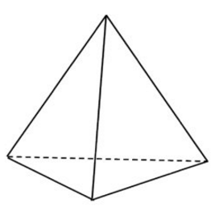
How to make your own tetrahedron ?
Combinatorial properties: | Vertices  edges  faces
Net:
Skeleton Graph:

