Multilingualism and Language Policies across Europe

Gabrielle Hogan-Brun, University of Bristol, UK

Email: g.hogan-brun@bristol.ac.uk

Overview

- Language policy and multilingualism
objectives, goals

- Approaches to multilingualism
in the West
in the Baltic countries

- Case study: The Baltic states
language policy, language use, dissonances
EU accession and effects of western monitoring

4. New multilingualisms

- Outlook
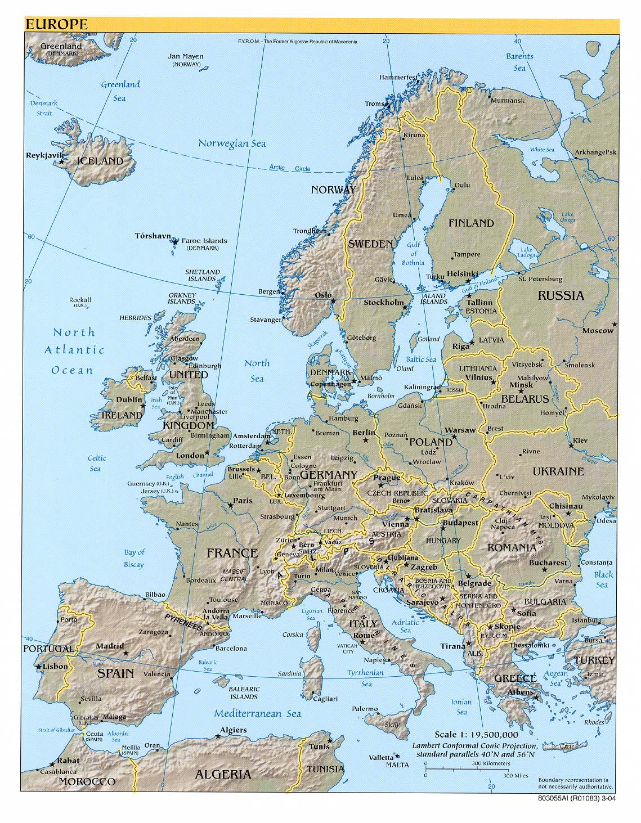

Further information and relevant publications are available on the following website:

http://www.bris.ac.uk/education/people/academicStaff/edgshb/publications

